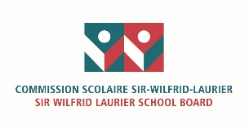 | END-OF-YEAR EVALUATION  Anti-Bullying, Anti-Violence Plan (ABAV) | 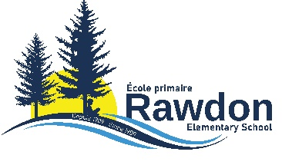
Art 83.1. (Ed. Act) “ Each year, the governing board shall evaluate the results achieved by the school with respect to preventing and dealing with bullying and violence. A document reporting on the evaluation must be distributed to the parents, the school staff and the regional student ombudsman in charge of accountability assigned to the region in which the school is located.”

.”

2025-2026
School | Rawdon Elementary School |  | Shared with Governing Board | May 12th, 2026  GB-165-20260512-06
Principal/Centre Director | Chantal Ouimet |  | Shared with  Teacher Council / Staff | May, 7th 2026
 |  |  | Shared with Parents | May 12th, 2026

 |  |  | Submitted to PSD Director and Director General | May 12th, 2026

ABAV Priorities
To foster an environment that enables a positive sense of belonging in students. To reduce the amount of bullying. To improve communication skills among the students in the school. To educate and sensitize students on how to form proper interpersonal relationships and engage in effective interactive play. To better educate students on the definition of bullying and the various types.

Actions / Initiatives to Maintain or Let Go (Prevention Measures)
- The school’s code of conduct
- Reinforcing and teaching of Self-Regulation Coping strategies and Socio-Emotional Learning (SEL)
- Explicitly model and teach expected behaviors.
- Provide active supervision: interact with as many students as possible, move around the space, and scan the area systematically.
- Incorporate tools and activities to build social skills and self-regulation techniques.
- Bring the student file to TEAM and/or Interdisciplinary Team (IDT) meetings for discussion.
- Rewarding kind behaviour, nice gestures and positive leadership.
- Have activities that promotes cooperation between older and younger groups.
- Discussing issues as a community in monthly assemblies
- Have school-wide causes or activities
- Outdoor yard offering multiple various activities
- School wide Breakfast program-
- The use of restorative practices across all cycles (including preschool) to increase empathy and self-awareness.
- Special Education Technician working with small groups to further develop social skills.
- The use of a schedule for certain school yard zones (soccer field, snow hill).

Actions / Initiatives to Maintain or Let Go (Sexual Violence)
- Entente de service with Marie-Vincent Foundation
- Workshops with Enfance Libre Lanaudière
- CCQ/Sexuality Education curriculum
- Reporting any acts on ISM

Actions / Initiatives to Maintain or Let Go (Bullying or violence based on factors such as skin color and ethnic or national origin)
Workshops for students on positive self-affirmation and appropriate responses when faced with discriminatory statements or actions.

Actions/initiatives to be developed next year
Hors-Piste program to be introduced in Grades 4-5-6. (Implementation had to be postponed this year).

